**APPENDIX E**

**PROJECT DOCUMENTATION**

Student’s Learning Experience

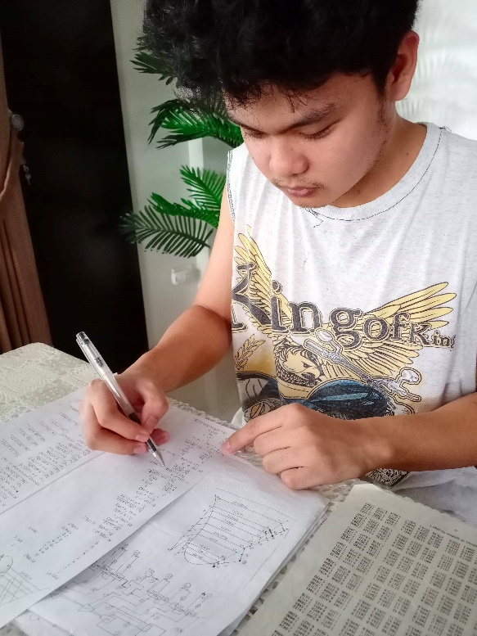Our design focuses on the coal-fired power plant with a cycle of reheat regenerative which I am familiarized with. But later on, it is seemingly difficult to deal-with because it primarily needs analysis and formula derivations on the system. I have learned the basic design aspects of a coal-fired power plant by its components, its process, and how the cycle works. I used to improve the efficiency of the power plant by adding heaters on the system. Also, by using the standard for the power plant design and operation, I meet the standard requirements and procedures in order to design an efficient power plant. We also study the parameters affecting the power plant design such as the site location, selection of proper fuel and consumption, source of water and its environmental conditions.

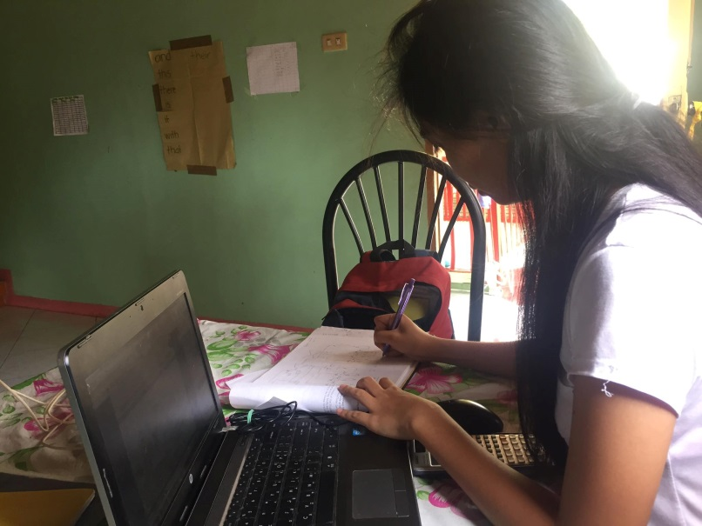For the proposed design of a coal-fired power plant, we were able to learn how a reheat-regenerative cycle works. At first, the task was hard to understand but as time goes by, we became more familiar with the design and the equipment used in a power plant. From the design, I became familiar with the process on how a steam power plant works from burning of fuel to generating electricity and distributing it with the different utilities in Batangas. Considerations were also made in choosing the best location such as the environmental aspects since the proposed plant is expected to operate for several years. We noticed that adding a reheater gives a higher value of efficiency of the power plant. The distance between the members became hindrance when it comes to a clear communication with the ideas of the members regarding the technicalities of the design and to deal with the various unexpected problems that comes along the way but these hardships somehow made the course of making the project more exciting and worthwhile.

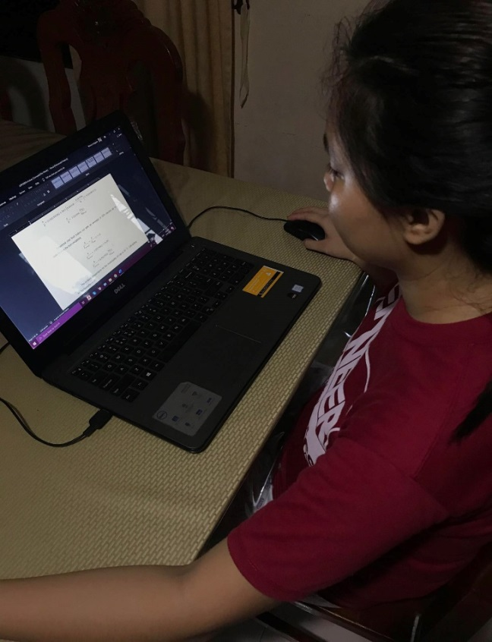I learned the basic knowledge and principle on how to design a coal fired power plant with a cycle of reheat regenerative. Thorough analyzation and examination must be considered to comply the requirements for an effective and efficient design. The subjects such as thermodynamics and refrigeration systems are very important since the formula are used in analyzing the diagram to proceed with the mass balances needed for the design and engineering management, It is very important to familiarize each with the requirements of the equipment and its functions involved in the design and construction of a power plant. I understand the most important aspect in designing a coal-fired power plant with a cycle of reheat regenerative, that is by doing the work together and by understanding the plan together.

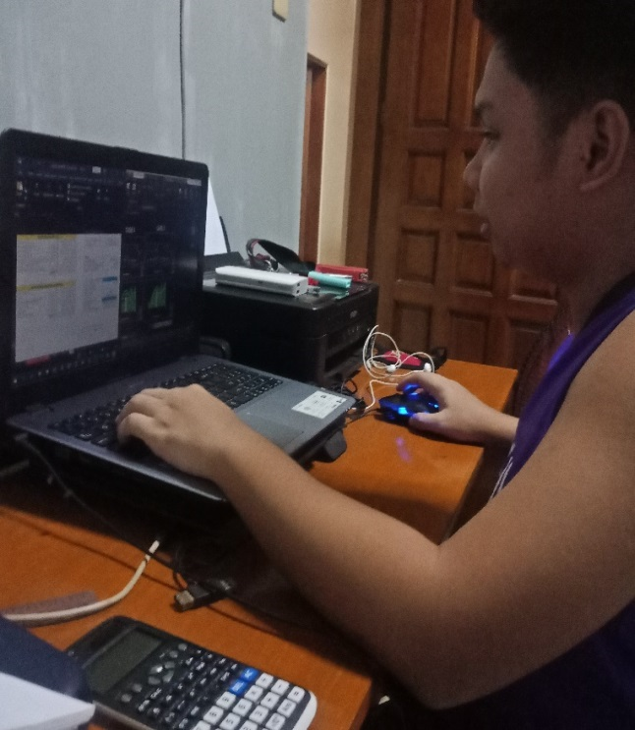I learned the basic knowledge and understanding on how to design a coal-fired power plant, I learned that the basis of the design can be found on the different module on the internet. It is important to have a proper analyzation of calculation before proceeding to another step, one small mistake could lead to a large issue, since the value would vary in choosing the proper equipment, although the values found in the catalog has a little difference but the costing would be different. In calculation I learned different formulas and different approach on how to increase the efficiency of the power plant. I also learned to analyze economic to help view the profits and to create the most competitive and productive product.

I learned a lot of things in doing our capstone. Designing a power plant requires a thorough research and careful considerations since there are many conditions that can affect the design of a power plant and factors that must be taken into account. The coal-fired power plant is the type that we chose since we had basic knowledge about steam and that we are familiar with the diagrams and systems that we had encountered in Thermodynamics. This in turn made me gain more understanding of the different components and processes in a coal-fired type plant and that careful calculations must be done. It is important to have a design that is both efficient and economical so as to achieve a desirable plant. The cooperation of each member of the team is also needed so that we can do our project effectively.

Below are the three design options made before the selection of the best design:

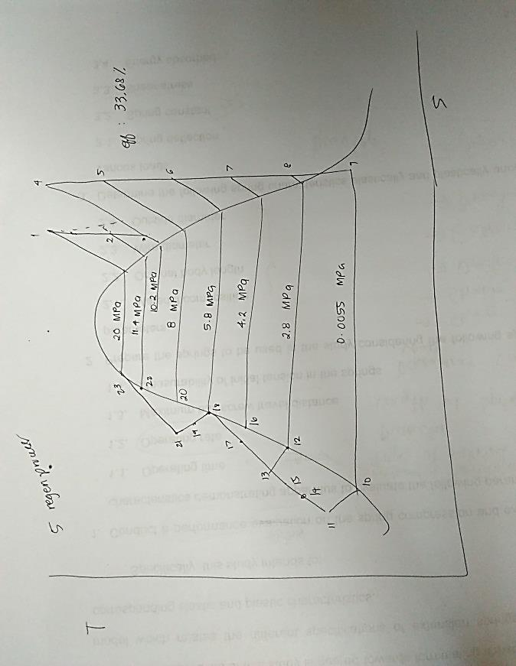

Design Option 1

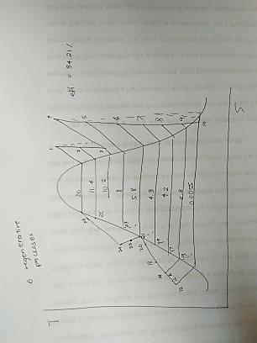

Design Option 2

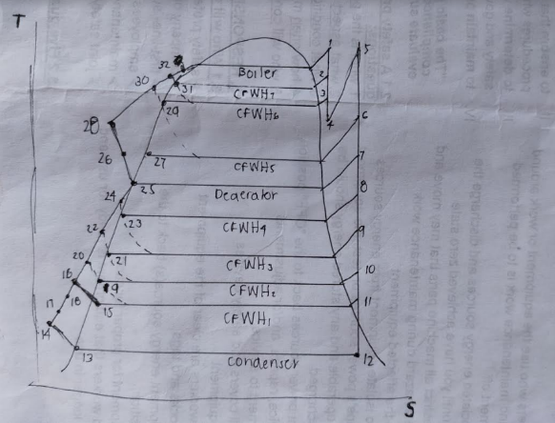

Design Option 3

Assumptions were made in order to come up with the best design option for the proposed power plant. From the options above, we concluded that design option 3 has the most efficient design.